MAPPING RELIGIOUS MODERATION STRATEGIES: A BIBLIOMETRIC ANALYSIS

Indun Fanani^{1*}

¹ Universitas Islam Negeri, Ponorogo, Indonesia
² Second author’s Affiliation, City, Country
³ Third author’s Affiliation, City, Country
*Corresponding author: name@xxxx.com

ARTICLE HISTORY:  Received :  Revised :  Accepted :  Published :  KEYWORDS:  Religious Moderation, Tolerance, Bibliometrics, VOSviewer | ABSTRACT  Religious Moderation Village (KMB) is one of the initiatives launched by the Ministry of Religious Affairs of the Republic of Indonesia to create a harmonious and tolerant environment amid religious diversity in Indonesia. The program aims to build public awareness by applying religious moderation through various collaborative and participatory implementation strategies. Religious moderation has become an increasingly relevant topic in academic discourse and public policy in Indonesia, especially in the context of Indonesia's pluralistic society. This research used a literature review, data retrieved from the Scopus database, and VOSviewer analysis. where the data are taken from the Scopus database, with a total of 695 publications in the range of 1988-2024. Data analysis was conducted using VOSviewer software to map research trends, academic collaborations, and key contributions to the global study of religious moderation. The findings show that Indonesia plays an important role in religious moderation literature, making it one of the world’s main centres of discussion. This study reveals patterns of interconnectedness among researchers, institutions, and the main concepts developed in research related to religious moderation. Compared to previous studies, the main contribution of this research is to provide a comprehensive mapping of publication trends and the development of religious moderation discourse in scholarly literature, as well as to identify research gaps that could be an opportunity for further studies. The results of this study are expected to provide insights for academics, policymakers, and practitioners in designing more effective strategies to strengthen religious moderation in society.

Citation: https://doi.org/xxxxxxxxxx

INTRODUCTION
Religious moderation is a concept that aims to balance the expression of faith with respect for diversity and the rights of others. In Indonesia, religious moderation is part of the national agenda to create harmonyamid different beliefs. The government and relevant institutions promote religious moderation to maintain social and political stability, overcome radicalism, and build interfaith harmony.One of the concrete initiatives in the implementation of religious moderation is Kampung Moderasi Beragama (KMB), developed by the Ministry of Religious Affairs of the Republic of Indonesia. The RTC serves as a model communitywhich implements the values of religious moderation through a cross-sectoral approach,involving local governments, religious leaders, and civil society organizations.The RTC's main strategies include (1) strengthening moderate attitudes through education and socialisation, (2) strengthening social harmony by encouraging interfaith dialogue,(3) improving the quality of inclusive public and religious services, and (4) developing community-based economy to improve people's welfare.
Although religious moderation has been the focus of various studies, some gaps remain to be addressed. First, previous studies have mostly discussed religious moderation in the context of national policies and the role of religious institutions, whereas studies on implementation at the community level are still limited. Second, few studies have used a bibliometric approach to map the trend of global religious moderation research, especially in the Indonesian context. Third, the direct impact of the Religious Moderation Village on society in the long term has not been systematically analysed. Therefore, this research aims to fill this gap by mapping the development of religious moderation studies and highlighting the implementation of the RTC as a community-based case study.

METHODS
In bibliometric analysis, indicators are applied in the evaluation of bibliographic data that have been obtained, including the number of authors, articles, citations, institutions, and countries. The documents used to analyze are obtained from the world's largest database of reputable international journals, Scopus.The availability of more articles in Scopus compared to Google Scholar or others. The author does not currently retrieve or use data from Google Scholar or others, as according to Aguillo there are issues with indexing, lack of formal integration in many cases. In the analysis structure used in the current study is in line with several bibliometric studies conducted on other topics. Data were collected from articles, books, anthologies, conferences, and reviews by authors. The data were retrieved on 4 November 2024 through its database Scopus using the keyword "Religious Moderation" to obtain 695 documents. Inclusion and exclusion criteria were applied to ensure the relevance and quality of the analysed documents. The inclusion criteria included articles that contained the keyword "religious moderation" in the title, abstract, or keywords; were published in scientific journals indexed in Scopus; and belonged to document types such as journal articles, conference proceedings, books, and reviews. Meanwhile, the exclusion criteria included documents that were not available in the full text, irrelevant to the Indonesian religious or social context, and non-scientific or editorial publications. Then, the selected article documents from the Scopus database were saved in the form of CSV files and analysed using two methods: analysis of search results on the Scopus menu and analysis using VOSviewer software. Analysis of Scopus search results, which included the number of publications, annual trends, and distribution of publications by institution and country. Bibliometric analysis using VOSviewer visualises research networks based on co-authorship (co-authorship), co-citation (co-citation), co-occurrence, keywords (co-occurrence of keywords), and bibliographic coupling (bibliographic coupling),butdefines co-authorship as an indicator to evaluate the most productive article collections, especially those with a co-publication rate, but this time I will analyse co-authorship by country and keyword analysis.

FINDINGS
The number of publications related to religious moderation has steadily increased in the past five years, especially after 2019, when the Indonesian Ministry of Religious Affairs included religious moderation as a national agenda. Most studies come from the fields of religious studies, education, and social sciences. This trend shows the growing attention of academics towards strengthening religious moderation as a response to the rising challenges of intolerance and radicalism. Temporal analysis also shows a significant spike in publications since 2020, indicating that this issue has become increasingly relevant in the context of national and global socio-political dynamics, especially in response to post-pandemic social change and increasing religious polarisation.
When compared to previous research such as that conducted by Subandi and Amirunnaufal (2023), which also used a bibliometric approach but was limited to an initial search with a smaller number of documents, this study provides a more comprehensive mapping with broader data coverage (695 documents). While the previous study focused more on author network visualisation and basic trends, this study deepens the analysis of cross-country collaborations, keyword relationships, and institutional distribution, which shows the involvement of academic actors globally. Thus, this study not only expands the scope of religious moderation bibliometrics, but also strengthens Indonesia's position as a centre of study and practice in this field.
From the Scopus database, with a search through the keywords "religious moderation" in general, there are 695 documents. From the data search with keywords that have been done through the Scopus database, the author will analyse the VOSviewer bibliometric application. First, articles related to the article "Religious Moderation" will analyse co-authorship–author, analysis of all authors who have published their articles in Scopus-indexed journals. The results obtained from the VOSviewer bibliometrics can be seen in the following image.
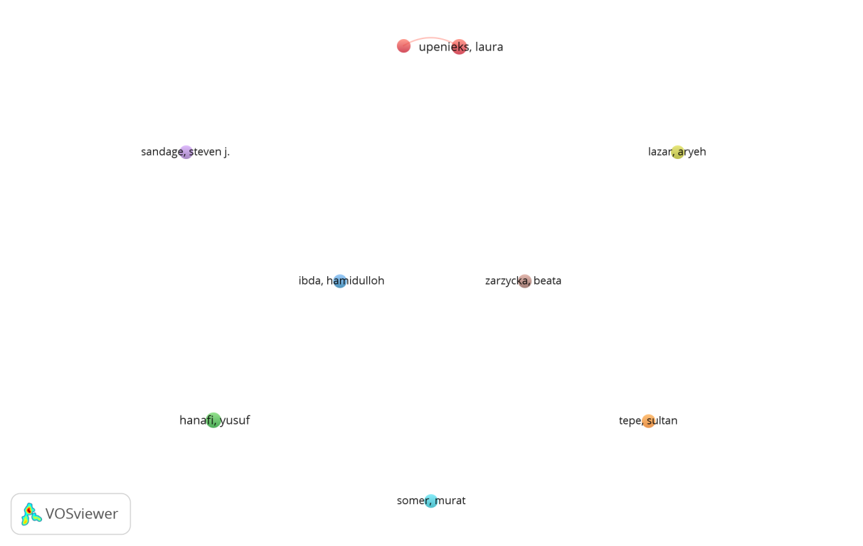
Figure 1. Co-Authorship - Analyzing Authors of Religious Moderation Articles

From the figure above, documents obtained from the 1738 Scopus database have nine authors, with 38 documents filtered. The results of the analysis show a pattern of collaboration between researchers in the field of religious moderation studies. Authors with high connectedness or close collaboration with other researchers, namely "upenieks, laura" become important figures in the research community. The details are listed in the following table:
Table 1. Co-Authorship - Analyzing Authors of Religious Moderation Articles
No | Author Name | Cluster | Number of Documents | Number of Citations | Average Publication Year | Average Citation
1 | Hanafi, Yusuf | 2 | 5 | 5 | 2023.2 | 1
2 | Hill, Terrence D. | 1 | 4 | 59 | 2021 | 14.75
3 | Ibda, Hamidulloh | 3 | 4 | 17 | 2023.5 | 4.25
4 | Lazar, Aryeh | 4 | 4 | 15 | 2020 | 3.75
5 | Sandage, Steven J. | 5 | 4 | 29 | 2020 | 7.25
6 | Somer, Murat | 6 | 4 | 255 | 2012.25 | 63.75
7 | Tepe, Sultan | 7 | 4 | 37 | 2014.25 | 9.25
8 | Upenieks, Laura | 1 | 5 | 10 | 2023 | 2
9 | Zarzycka, Beata | 8 | 4 | 39 | 2018.75 | 9.75

Furthermore, the discussion or analysis of articles with the keyword "religious moderation" was followed by analysing co-authorship-countris. The analysis here is based on all countries that published their articles in Scopus-indexed journals. The results obtained from the VOSviewer bibliometrics are shown in the following figure:
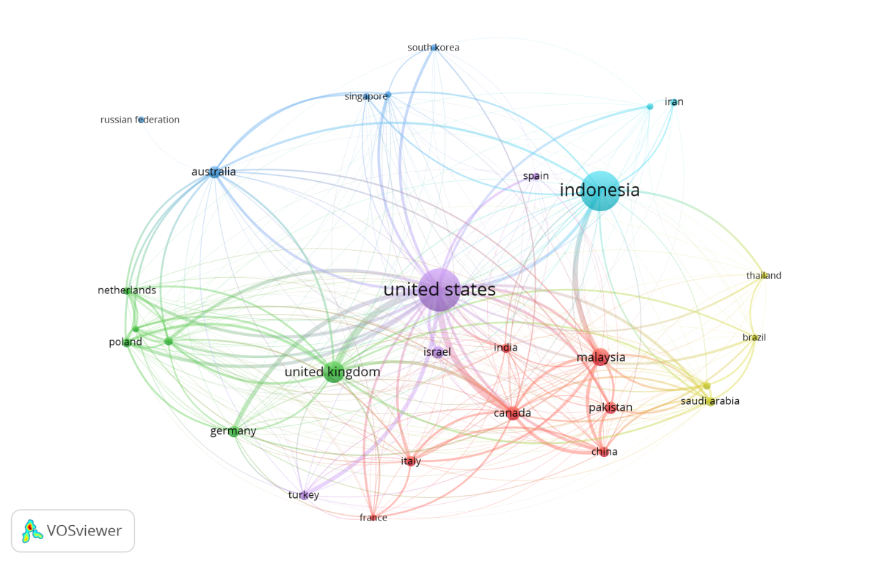
Figure 2 Co-Authorship - Analyzing Countries Religious Moderation Articles
From Figure 2 above, in writing the article "Religious Moderation" based on Vosviewer analysis, 73 countries meet the threshold by applying a filter of one document. Documents obtained from the Scopus database were 518 article documents, which were divided into 16 country clusters. Cluster 1 included Australia, China, Denmark, Germany, Kenya, Pakistan, and the United Arab Emirates; cluster 2 included Austria, Hungary, Iran, Poland, South Africa, and the United Kingdom. Cluster 3: Ethiopia, Israel, Nigeria, Turkey, and the United States; Cluster 4: Canada, France, Ireland, Italy, and Sweetzerland; Cluster 5: Brunei Darussalam, Egypt, Indonesia, Pelita Harapan University; Cluster 6: Bangladesh, Czech Republic, Malaysia; Cluster 7: Chile, Mexico, Spain; Cluster 8: India, Japan; Cluster 9: Saudi Arabia and Tunisia; Cluster 10: Hong Kong, South Korea; Cluster 11: Sweden, Thailand; Cluster 12: Netherlands; Cluster 13: Morocco; Cluster 14: New Zealand; Cluster 15: Norway; Cluster 16: University of Minesota.
The purpose of country co-authorship analysis is to examine and determine the level of communication and influence between countries in the field of "Religious Moderation". The colours of the assigned nodes correspond to the separate clusters. The links between nodes indicate the relationship between countries, and the thickness of the links and distance between nodes indicate the level of collaboration between countries. Large nodes indicate a large number of countries. As shown in the figure, the centre of the network is in the United States, with the proximity of the node to Indonesia.
Third, analysis of "religious moderation" articles by analysing co-occurrence-author keywords. The results of the VOSviewer analysis are shown in the table and figure below:

Table 2: "Religious Moderation" based on co-Occurrence-Author keywords.
No | Keyword | Occurrences | Total link strength
1  2  3  4  5  6  7  8  9  10 | Religious moderation  Religion  Moderation  Indonesia  Religiosity  Depression  Islam  Tolerance  Spirituality  radicalism | 77  58  65  24  47  15  21  18  15  14 | 26  24  19  15  14  12  12  12  11  9
Source: Scopus database
From Table 2, in writing the article "Religious Moderation" which is based on keyword analysis of data with a total of 1967 keywords, there are 10 keywords in the threshold, with a filter applied to 14 documents. From these results, 10 keywords met the threshold. The keyword "religious moderation" has a strong relationship with various concepts, such as tolerance, radicalism, and the Indonesian context. This reflects the importance of research on religious moderation as a strategy for counteracting radicalism and promoting social harmony. The keyword Indonesia stands out in the green cluster, indicating that the country is a focus of research on religious moderation, perhaps because the diversity and dynamics of religion in Indonesia are different from those in other countries. The results in tabular form can then be seen in the visualisation of the image, as shown in Figure 3 below:
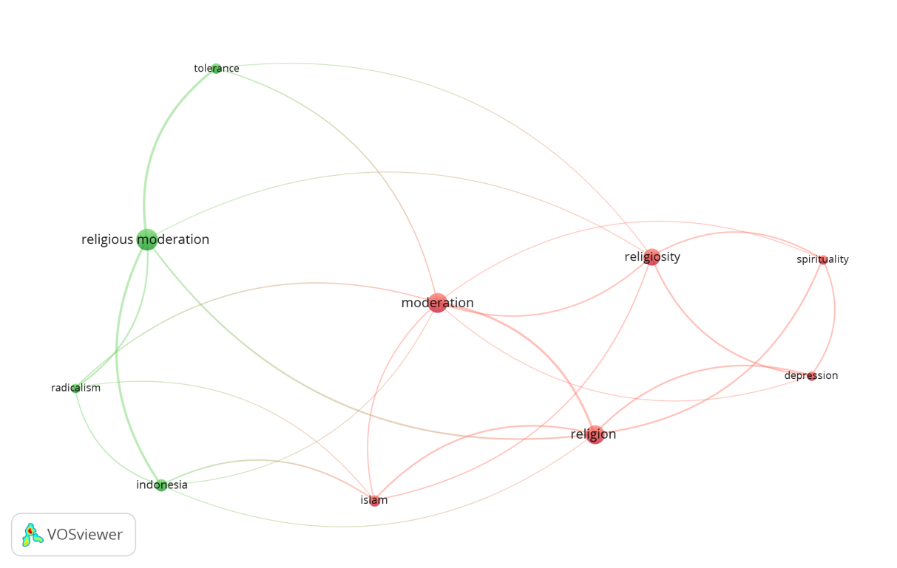
Figure 3. Co-Occurrence - Author Keywords of the Article "Religious Moderation"

The figure shows the co-occurrence network map generated from bibliometric analysis using VOSviewer. This map shows the relationship between keywords in the literature related to "religious moderation". The links between nodes indicate strong interrelationships between keywords. Different node colours indicate the clustering of themes. Nodes green, main keywords: religious moderation, tolerance, radicalism, Indonesia. Focusing on religious moderation in the Indonesian context, the keywords radicalism and tolerance indicate that religious moderation is associated with efforts to prevent radicalism and promote tolerance. Red nodes, main keywords: moderation, religion, religiosity, Islam. This cluster explored the relationship between moderation, religion, and religiosity. The keyword Islam stands out, indicating a focus on Islam in the discussion on moderation. Pink, main keywords: spirituality, depression, and religiosity. This cluster demonstrates the relationship between religiosity, spirituality, and their impact on psychological well-being, including their relationship to issues such as depression.

DISCUSSION
The present study was designed to fill the gaps identified in previous research on religious moderation, specifically regarding the lack of bibliometric mapping and the limited analysis of community-based implementation, as outlined in the Introduction. By applying bibliometric analysis using Scopus data and VOSviewer, this research successfully mapped the global research trends, collaborations, and dominant themes in religious moderation literature, providing new insights into the evolving academic landscape of this topic.
One of the key scientific interpretations from the findings is the growing centrality of Indonesia in the global religious moderation discourse. This prominence can be attributed to the unique socio-religious context of Indonesia as a Muslim-majority nation that constitutionally embraces religious pluralism. The strong relationship between keywords such as religious moderation, tolerance, radicalism, and Indonesia indicates that religious moderation is not only a theoretical framework but also a practical response to social challenges such as radicalization and interfaith tensions. The emergence of "Religious Moderation Village" (Kampung Moderasi Beragama) initiatives has likely contributed to the increase in related academic output, demonstrating the interplay between policy implementation and academic interest.
When compared with prior studies, such as Subandi & Amirunnaufal (2023), which provided an initial bibliometric overview but with a smaller dataset, this study significantly expanded the data scope and analytical depth. The previous studies primarily emphasized co-authorship networks, while this research offered a more holistic view by integrating cross-country collaborations, keyword co-occurrence patterns, and institutional participation. Notably, while earlier studies tended to focus on Indonesia’s internal dynamics, this study demonstrates that religious moderation research has increasingly attracted international scholarly attention, as reflected by active contributions from researchers in countries like the United States, Turkey, Poland, and others. Nevertheless, the analysis also reveals a fragmentation in global research networks, where collaborations remain limited across countries and clusters, suggesting a need for broader international cooperation in future studies.

CONCLUSIONS
Strengthening religious moderation in Indonesia shows a positive trend in both academic attention and policy implementation. The results of the bibliometric analysis show that Indonesia is a major centre in the global discourse on religious moderation, with significant contributions from various institutions and researchers. The implementation of the Kampung Moderasi Beragama (KMB) strategy demonstrates the effectiveness of a collaborative approach to building an inclusive and harmonious society. The concrete implication of this research is the importance of strengthening international research networks and enhancing synergies among academics, policymakers, and civil society in developing evidence-based programs to strengthen tolerance values.
This study has limitations in data coverage that are only sourced from the Scopus database, so it does not represent literature from other platforms such as Google Scholar, DOAJ, or local repositories. In addition, the bibliometric approach does not explore the qualitative dimensions of article content, such as implementation strategies or the deep social impact of religious moderation. Future studies should use a mixed-method approach that combines bibliometric analysis with qualitative studies of implementing communities, such as RTCs, as well as expanding the scope of data from various sources and languages to obtain a more comprehensive picture.

ACKNOWLEDGMENT
The authors would like to thank VOSviewer bibliometrics, reference sources on religious moderation from Scopus-indexed journals, and lecturers on this bibliometric research assignment.

DECLARATIONS
Author Contribution | : | Inisial Author 1: Conceptualization, Data curation, Formal analysis, and Writing original draft.  Inisial Author 2: Funding acquisition, Investigation, Methodology, Supervision, Writing review, and Editing.  Inisial Author 3: Funding supporting, Project administration, Supervision, and Validation.  Inisial Author 4: Supervision, Validation, Visualization, Review, and Editing  (https://www.elsevier.com/authors/policies-and-guidelines/credit-author-statement)
Funding Statement | : | This study was not funded by any grant.
Conflict of Interest | : | The authors declare no conflict of interest.
Additional Information | : | Additional information is available for this paper.

BIBLIOGRAPHY
Aguillo, IF. (2012). Is Google Scholar useful for bibliometrics? A webometric analysis. Scientometrics, 91(2), 343–351.
Daheri, M., Warsah, I., Morganna, R., Putri, O. A., & Adelia, P. (2023). Strengthening Religious Moderation: Learning from the Harmony of Multireligious People in Indonesia. Journal of Population and Social Studies, 31, 571–586. Scopus. https://doi.org/10.25133/JPSSv312023.032
Febrina Yasmin Salsabila. (2019). Radikalisme Sebagai Bibit Perpecahan Antar Umat Beragama,. Jurnal Kewarganegaraan, 3(2).
Hanafi, Y. (2022). Students’ perspectives on religious moderation: A qualitative study into religious literacy processes. HTS Teologiese Studies / Theological Studies, 78(1). https://doi.org/10.4102/hts.v78i1.7638
Hati, L. P., al-Mujtahid, N. M., Kholil, S., Sahfutra, S. A., Ginting, L. D. C. U., & Fahreza, I. (2023). Religious Harmony Forum: Ideal Religious Moderation in the Frame of Building Tolerance in Medan City, Indonesia. Pharos Journal of Theology, 104(4). Scopus. https://doi.org/10.46222/pharosjot.104.420
Hill T.D., Andre Christie-Mizell C., Vaghela P., Mossakowski K.N., Johnson R.J. (2017). Do Religious Struggles Mediate the Association between Day-to-Day Discrimination and Depressive Symptoms? Religions, 8(8).
Ibda, H. (2024). Simaksaja: Visual novel game with TyranoBuilder software for Islamic moderation in elementary schools. International Journal of Electrical and Computer Engineering, 14(3). https://doi.org/10.11591/ijece.v14i3.pp2955-2964
Indainanto, Y. I., Dalimunthe, M. A., Sazali, H., & Kholil, S. (2023). Islamic Communication in Voicing Religious Moderation as an Effort to Prevent Conflicts of Differences in Beliefs. Pharos Journal of Theology, 104(4). Scopus. https://doi.org/10.46222/pharosjot.104.415
Kamali, M. H., & Ramadan, T. (n.d.). The Middle Path of Moderation in Islam: The Qur’anic Principle of Wasatiyyah.
Kemenag RI. (2024). Strategi Pengembangan Kampung Moderasi Beragama.
Kementerian Agama RI. (2019). Moderasi Beragama. Kementerian Agama RI.
Keputusan Direktorat Jenderal Bimbingan Masyarakat Islam Kementerian Agama Republik Indonesia. (2023). Pedoman Pembentukan Kampung Moderasi Beragama.
Kessler, MM. (1963). Bibliographic coupling between scientific articles. American Documentation, 24, 123–131.
Lazar A. (2017). Pribumisasi Dalam Pandangan Abdurahman Wahid, Religious. Jurnal Studi Agama-Agama Dan Lintas Budaya, 2(1).
Lestari, N.D. (2024). Program Kampung Moderasi Beragama sebagai Perwujudan Toleransi Antar Umat Beragama di Desa Ngablak. Pelita: Jurnal Pengabdian Kepada Masyarakat.
M. Amin Abdullah. (2019). Islam Nusantara dan Budaya Damai. UIN Sunan Kalijaga Press.
Martínez-L´opez, FJ, Merig´o, JM, Valenzuela-Fern´andez, L. dan Nicol´as, C. (2018). Fifty years of European marketing journals: A bibliometric analysis. European Journal of Marketing, 52(1/2), 439–468.
Mongeon, P. dan Paul-Hus, A. (2016). Scopus and Science Web Journal Coverage: Comparative Analysis. Scientometrics, 106(1).
Oman Fathurahman(Ketua Tim Pokja Moderasi Beragama Kementerian Agama RI), O. F. (2024, Desember Pukul. 19.29). “Mengapa Harus Moderasi Beragama?” https://kemenag.go.id/opini/kenapa-harus-moderasi-beragama-an4gk2
Pajarianto, H., Pribadi, I., & Sari, P. (2022). Tolerance between religions through the role of local wisdom and religious moderation. HTS Teologiese Studies / Theological Studies, 78(4). Scopus. https://doi.org/10.4102/hts.v78i4.7043
Putri, P. W., Huda, M., Mujib, A., Sakinah, S., Humaidi, Z., Putri, A. S., & Muna, A. N. (2024). POTRET KAMPUNG MODERASI BERAGAMA KELURAHAN PAKELAN, KOTA KEDIRI. Al-Mabsut : Jurnal Studi Islam Dan Sosial, null, null. https://doi.org/10.56997/almabsutjurnalstudiislamdansosial.v18i1.1531
Sandage S.J., Paine D., Hill P. (2015). Spiritual barriers to humility: A multidimensional study, Mental Health, Religion & Culture. 18(3), 207–217.
Siswanto, Aksa, A. H., Sahrudin, M. I. M., & Wafa, M. S. (2024). Kampung Moderasi Beragama; Merajut Kerukunan Umat Beragama Melalui Modal Sosial di Desa Tempur. NAJWA: Jurnal Pengabdian dan Pemberdayaan Masyarakat, 2(1). https://doi.org/10.30762/najwa.v2i1.259
Smith, R. J., & Bryant, R. G. (1975). Metal substitutions incarbonic anhydrase: A halide ion probe study. Biochemical and Biophysical Research Communications, 66(4), 1281–1286. https://doi.org/10.1016/0006-291x(75)90498-2
Somer M. (2007). Moderate Islam and secularist opposition in Turkey: Implications for the world, Muslims and secular democracy, Third World Quarterly. 28(7), 1271–1289.
Subandi Yeyen & Muhammad Amirunnaufal. (2023). Moderasi Beragama di Indonesia: Sebuah Analisis Bibliometrik VOSviewer. Primer: Jurnal Ilmiah Multidisiplin, 1(4).
Tepe S. (2005). Religious parties and democracy: A comparative assessment of Israel and Turkey, Democratization. 12, 283–307.
Usman, A. R., Sulaiman, A., Zulyadi, T., Fauzan, A., Salahuddin, A., Putri, N., Jannah, M., & Misra, L. (2024). RELIGIOUS MODERATION THROUGH PERSIA-ACEH INTERCULTURAL COMMUNICATION. Jurnal Ilmiah Islam Futura, 24(2), 471–487. Scopus. https://doi.org/10.22373/jiif.v24i2.17443
Van Eck, NJ dan Waltman, L. (2010). Survey Software: VOSviewer computer program for bibliometric mapping. Scientometrics, 84(2), 523–538.
Verma, S. dan Gustafsson, A. (2020). Investigation of emerging COVID-19 research trends in business and management: A bibliometric analysis approach. Journal of Business Research, 118, 253–261.
Zarzycka B., Sliwak J., Krok D., Ciszek P. (2019). Religious comfort and anxiety in women with cancer: The mediating role of hope and moderating role of religious struggle, Psychooncology. 28(9), 1829–1835.

(Oman Fathurahman(Ketua Tim Pokja Moderasi Beragama Kementerian Agama RI), 2024)
(Kamali & Ramadan, n.d., p. 9)
(Indainanto et al., 2023)
(Febrina Yasmin Salsabila, 2019, p. 99)
(Kementerian Agama RI, 2019, pp. 15–19)
(Hati et al., 2023, p. 420)
(Kemenag RI, 2024)
(Usman et al., 2024)
(Pajarianto et al., 2022)
(Keputusan Direktorat Jenderal Bimbingan Masyarakat Islam Kementerian Agama Republik Indonesia, 2023)
(Putri et al., 2024)
(Siswanto et al., 2024)
(Daheri et al., 2023)
(Lestari, N.D, 2024)
(Siswanto et al., 2024, p. 529)
(Mongeon, P. dan Paul-Hus, A, 2016, pp. 213–228)
(Verma, S. dan Gustafsson, A, 2020, pp. 253–261)
(Aguillo, IF., 2012)
(Verma, S. dan Gustafsson, A, 2020)
(Van Eck, NJ dan Waltman, L, 2010)
(Kessler, MM, 1963)
(Van Eck, NJ dan Waltman, L, 2010)
(Martínez-L´opez, FJ, Merig´o, JM, Valenzuela-Fern´andez, L. dan Nicol´as, C., 2018)
(M. Amin Abdullah, 2019, pp. 120–124)
(Hanafi, Y., 2022)
(Hill T.D., Andre Christie-Mizell C., Vaghela P., Mossakowski K.N., Johnson R.J., 2017)
(Ibda, H., 2024)
(Lazar A, 2017)
(Sandage S.J., Paine D., Hill P., 2015)
(Somer M, 2007)
(Tepe S., 2005)
(Smith & Bryant, 1975)
(Zarzycka B., Sliwak J., Krok D., Ciszek P., 2019)
(Oman Fathurahman(Ketua Tim Pokja Moderasi Beragama Kementerian Agama RI), 2024, pp. 2–3)
(Subandi Yeyen & Muhammad Amirunnaufal, 2023, pp. 45–47)
(Somer M, 2007, pp. 1273–1275)
(Tepe S., 2005, pp. 285–287)

